# Lab 1

## Compare PMLE with PBE:

Following results show the difference between ln results:



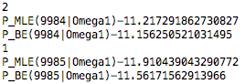

For words that never shows in the class, the Maximum Likelihood estimator PMLE=0, and ln(PMLE)= $-∞$. While Bayesian estimator ln(PBE) is a small number that will not cause the estimation of this class P(x|w) impossible.

For words that shows in the class, ln(PMLE) a little bit smaller than ln(PBE). Both ln(PMLE) and ln(PBE) will increase by the increase of the number of times word wk occurs in all documents in class.